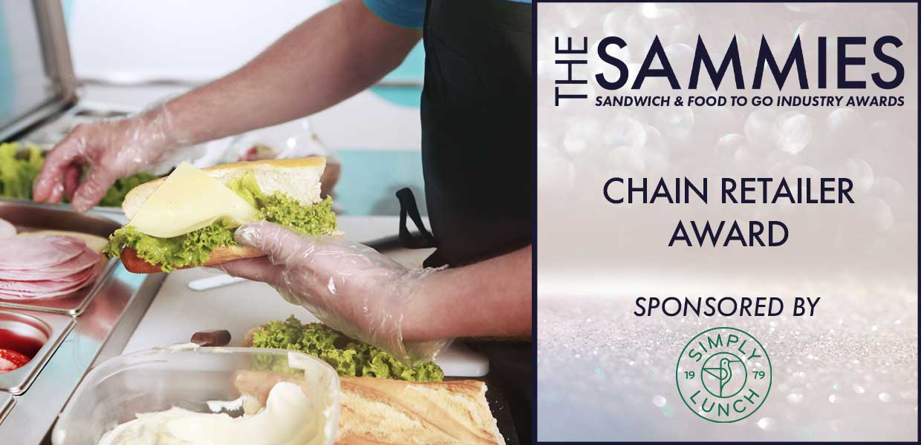
What We Look For
This award recognises excellence amongst sandwich and food to go retailers with more than 10 outlets. Whether products are made to order, pre-packed on site, or made in a central commissary, the judges will be looking to acknowledge those who are driving the business forward and who have achieved the most impressive development in the qualifying period.
All Chain Retailers with a Food Hygiene Rating of 5 are considered for this award however entries are encouraged.
The Award Qualifying Period is 1st March 2023 to 29th February 2024.
All entries will be treated in strict confidence and only seen by the judging panel.
How to Enter
Entrants should provide a written submission, no more than two sides of A4 and clearly state what they have been doing over the last 12 months including new initiatives, marketing campaigns, promotions etc.
Closing date for Entries: 7th February 2024.

Contact Name:
Position:
Store/Business Name:
Address:
Postcode:
Business Tel:
Mobile:
Contact E-Mail:
Food Hygiene Rating:

Please provide your written submission here
Continue as necessary to a maximum of two sheets of A4
Other supporting material may be sent separately

