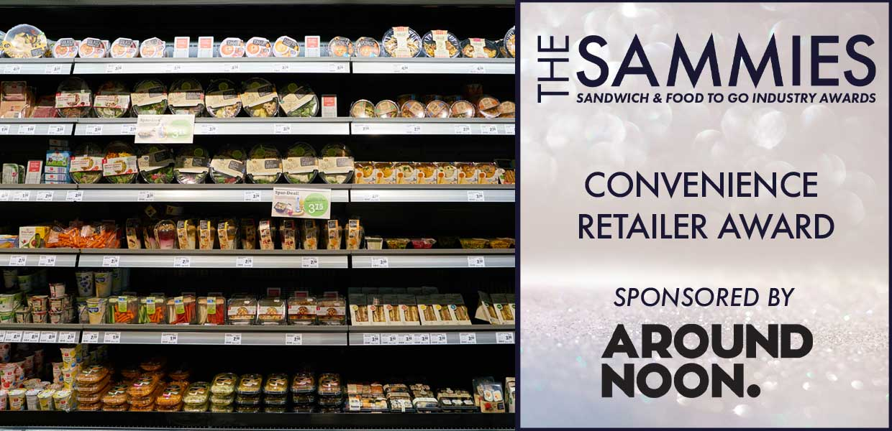
What We Look For
This award recognises the work being done by the convenience retailers to develop the Sandwich/FTG market in the high street. The judging panel will take into account the work undertaken together with market data sourced from Kantar, Lumina Intelligence and Mealtrak.
All convenience retailers are considered for this award however entries are encouraged.
The Award Qualifying Period is 1st March 2023 to 29th February 2024.
All entries will be treated in strict confidence and only seen by the judging panel.
How to Enter
Entrants should provide a written submission, no more than two sides of A4 and clearly state what they have been doing over the last 12 months including new initiatives, marketing campaigns, promotions etc.
Closing date for Entries: 7th February 2024

Contact Name:
Position:
Store/Business Name:
Address:
Postcode:
Business Tel:
Mobile:
Contact E-Mail:
Please provide your written submission here
Continue as necessary to a maximum of two sheets of A4
Other supporting material may be sent separately

