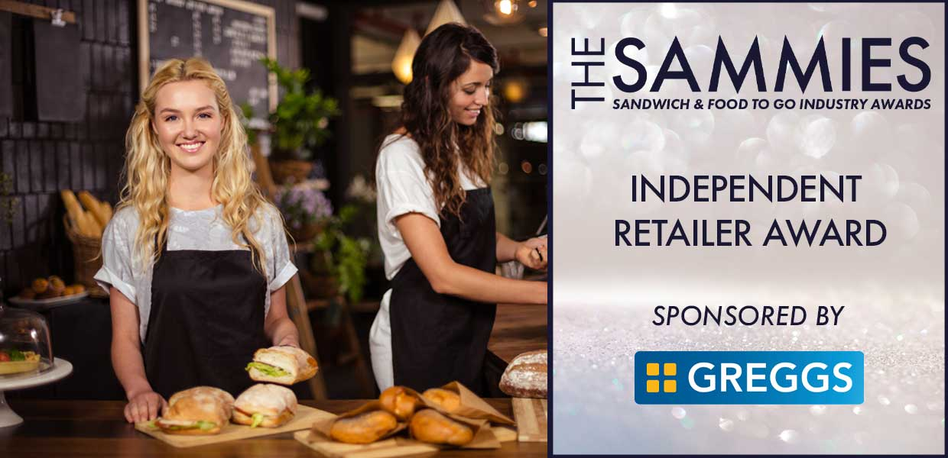

What We Look For
This award shines a spotlight on the independent retailers (up to nine stores) which so often lead the way in new trends and tastes.
The Award Qualifying Period is 1st March 2023 to 29th February 2024 and entrants must have a Food Hygiene Rating of 5.
All entries will be treated in strict confidence and only seen by the judging panel.
The judging process will include a mystery shopper visit conducted by ESA Retail.
How to Enter
Entrants should provide a written submission, no more than two sides of A4 and clearly state what they have been doing over the last 12 months including new initiatives, marketing campaigns, promotions etc.
Closing date for Entries: 7th February 2024

Contact Name:
Position:
Store/Business Name:
Address:
Postcode:
Business Tel:
Mobile:
Contact E-Mail:
Nominated Address for Judging:
Food Hygiene Rating:
Food Hygiene Rating Authority:

Please provide your written submission here
Continue as necessary to a maximum of two sheets of A4
Other supporting material may be sent separately

