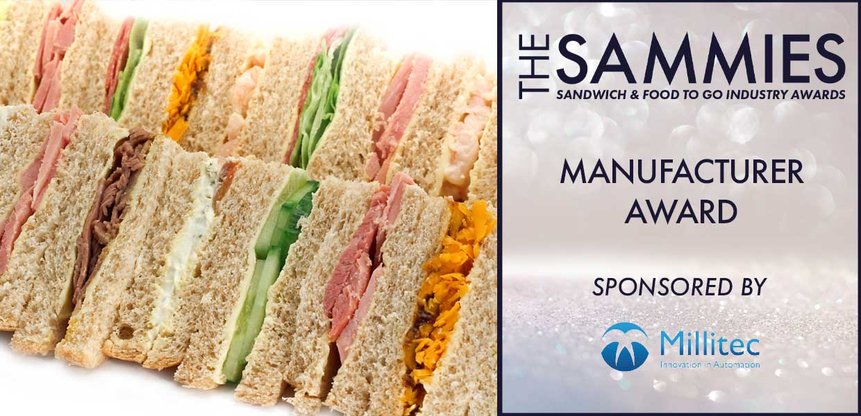
What We Look For
The judges will be looking at the contribution made by manufacturers to elevate and grow the industry. This may include initiatives to improve the quality and food safety of Sandwich and FTG manufacturing, investment in people and facilities, technical standards and product quality.
This award is open to members and Non BSA members, however non members must submit their British Retail Consortium (BRC) report with their entry and must have BRC, AA or AA+ grades.
The Award Qualifying Period is 1st March 2023 to 29th February 2024.
All entries will be treated in strict confidence and only seen by the judging panel.
How to Enter
Entrants should provide a written submission with supporting information wherever possible and no more than two sides of A4.
Closing date for Entries: 7th February 2024

Contact Name:
Position:
Business Name:
Address:
Postcode:
Business Tel:
Mobile:
Contact E-Mail:
Please provide your written submission here
Continue as necessary to a maximum of two sheets of A4
Other supporting material may be sent separately

