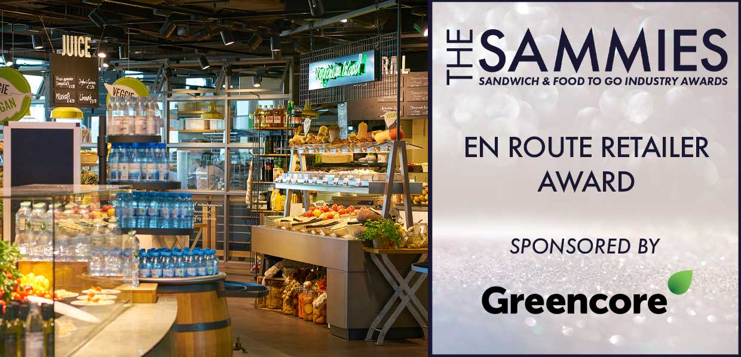

What We Look For
The judges will be looking for retailers (regardless of size and scale) who have been working hard to develop and drive the travel sector. From forecourts and service stations to airport and trains, the judges will be particularly looking at how they have managed their business over the last 12 months. Market data will also be sourced from Kantar, Lumina Intelligence and Mealtrak.
The Award Qualifying Period is 1st March 2023 to 29th February 2024.
All entries will be treated in strict confidence and only seen by the judging panel.
How to Enter
Entrants should provide a written submission, no more than two sides of A4 and clearly state what they have been doing over the last 12 months including new initiatives, marketing campaigns, promotions etc.
Closing date for Entries: 7th February 2024

Contact Name:
Position:
Store/Business Name:
Address:
Postcode:
Business Tel:
Mobile:
Contact E-Mail:
Please provide your written submission here
Continue as necessary to a maximum of two sheets of A4
Other supporting material may be sent separately

