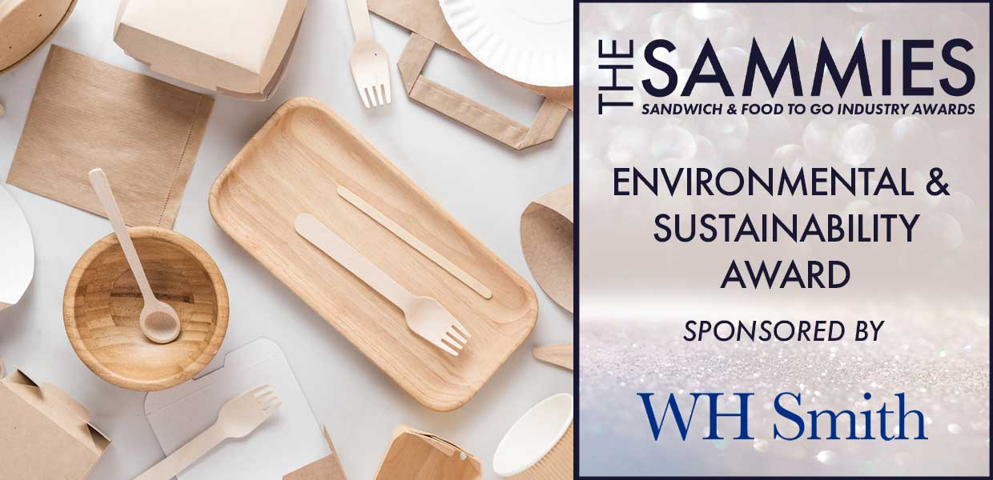

What We Look For
This award is designed to recognise the work being done at all levels of the industry to reduce the sector's impact on the environment and improve sustainability.
The Award Qualifying Period is 1st March 2023 to 29th February 2024.
Those shortlisted for this award will be invited to present (via Teams) to a panel of industry judges.
All entries will be treated in strict confidence and only seen by the judging panel.
How to Enter
Entrants should provide a written submission, no more than two sides of A4 together with supporting material and stating the environmental benefits gained.
Those shortlisted will be notified W/C: 19/02 and will be invited to present to the judging panel on Thursday 07/03.
Closing date for Entries: 7th February 2024

Contact Name:
Position:
Business Name:
Address:
Postcode:
Business Tel:
Mobile:
Contact E-Mail:
Please provide your written submission here
Continue as necessary to a maximum of two sheets of A4
Other supporting material may be sent separately

