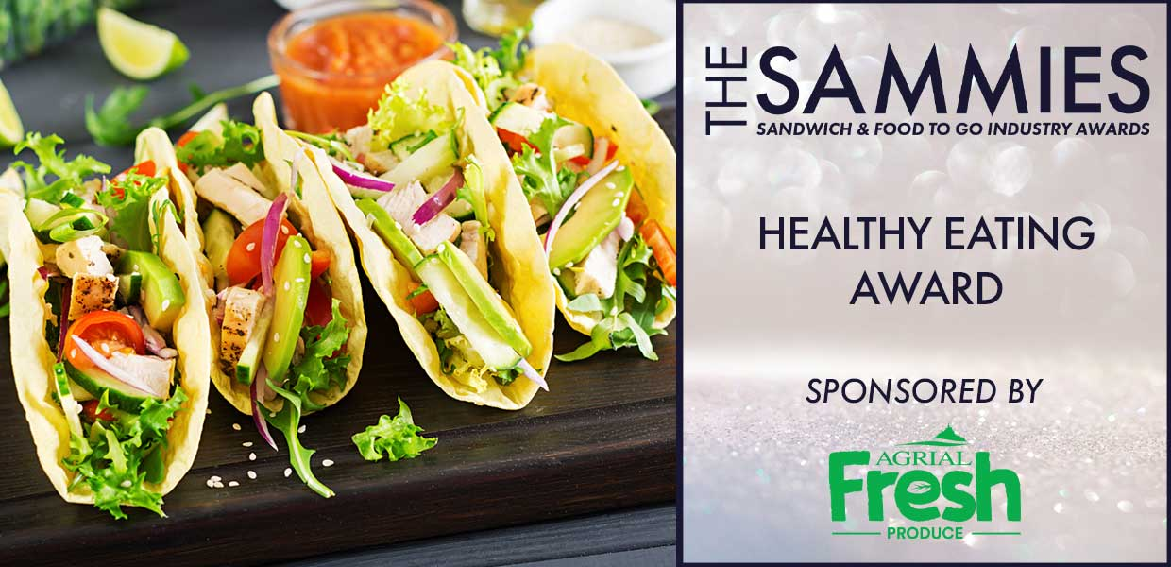
What We Look For
The judges will be looking at the work being done by businesses in the sandwich and food to go markets to provide consumers with new, interesting and innovative healthy eating products. They will take account of the calories in the product as well as the traffic light labels in accordance with the government HFSS target.
This award applies to a new product (not a range).
Entries must have been launched within the award qualifying period - 1st March 2023 to 29th February 2024.
All entries will be treated in strict confidence and only seen by the judging panel.
How to Enter
Entrants should provide a written submission, no more than two sides of A4 and MUST clearly state the market the product is aimed at (e.g. retail supermarket, foodservice) the selling price, why it is innovative and its value to the industry. Supporting material (product literature etc) may also be submitted with entries.
Those shortlisted for the first stage of judging will be notified W/C: 19/02 and sample products will be required for Thursday,14/03. Further details of where products are to be sent will be confirmed at the time. The final shortlisted entries will be notified W/C: 18/03 and will be invited to present to the judging panel on Wednesday, 27/03.
Closing date for Entries: 7th February 2024

Contact Name:
Position:
Business Name:
Address:
Postcode:
Business Tel:
Mobile:
Contact E-Mail:
Please provide your written submission here
Continue as necessary to a maximum of two sheets of A4
Other supporting material may be sent separately
Product Name:

Launch Date:

Price:

