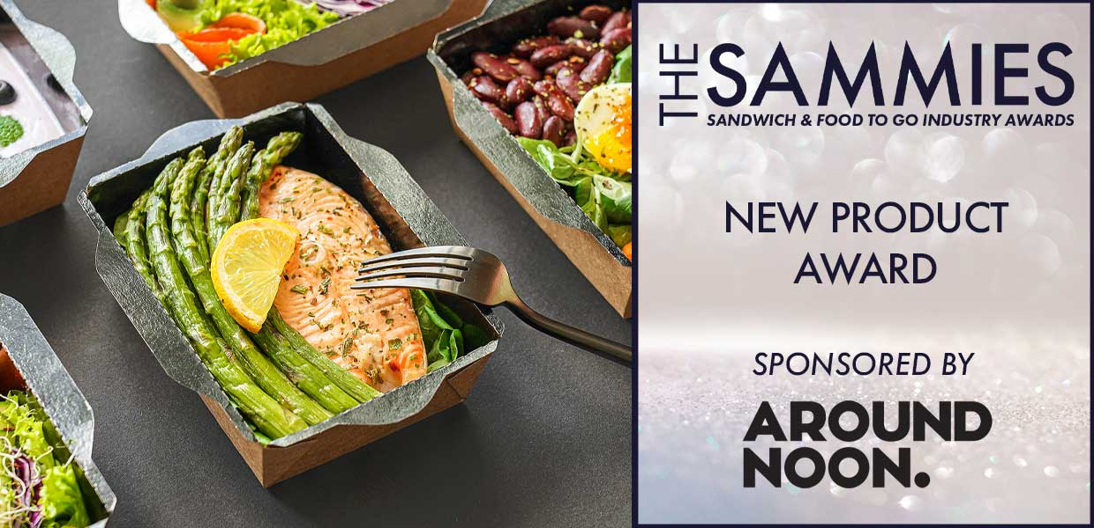
What We Look For
This award recognises development and innovation by suppliers within the industry and looks at both ingredients and packaging/equipment.
The judges will be looking for outstanding innovation and development in ingredients (not prepared sandwiches or food to go products) or packaging and equipment categories.
Entries must have been launched within the award qualifying period - 1st March 2023 to 29th February 2024.
All entries will be treated in strict confidence and only seen by the judging panel.
How to Enter
Entrants should provide a written submission, no more than two sides of A4 and MUST clearly state the market the product is aimed at (e.g. retail supermarket, foodservice) the selling price, why it is innovative and its value to the industry. Supporting material (product literature etc) may also be submitted with entries.
New Packaging/Equipment
Those shortlisted will be notified W/C: 19/02 and will be invited to present to the judging panel (via Teams) on Thursday, 07/03
New Ingredient
Those shortlisted will be notified W/C: 19/02 and sample products will be required for Tuesday,12/03. Further details of where products are to be sent will be confirmed at the time. The final shortlisted entries will be notified W/C:18/03 and will be invited to present to the judging panel (via Teams) on Tuesday 26/03
Closing date for Entries: 7th February 2024

Please Select a Category
Ingredient
Equipment / Packaging

Contact Name:
Position:
Business Name:
Address:
Postcode:
Business Tel:
Mobile:
Contact E-Mail:

Please provide your written submission here
Continue as necessary to a maximum of two sheets of A4
Other supporting material may be sent separately
Product Name:

Launch Date:

Price:

