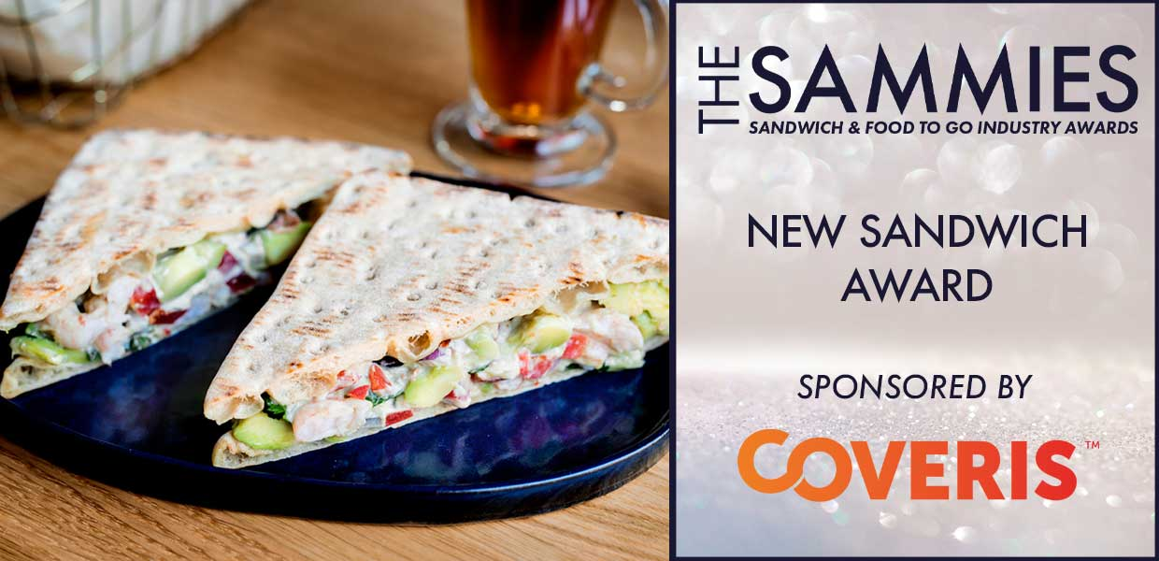
What We Look For
The judges will be looking for sandwich innovation and development and will take into account presentation and taste as well as commercial viability.
This award is open to any new sandwich (not a range) and includes sandwiches, baguettes, wraps, paninis etc.
Entries can be made in the following two categories:
- Hot
- Cold
Entries must have been introduced to the market within the award qualifying period 1st March 2023 to 29th February 2024. All entries will be treated in strict confidence and only seen by the judging panel.
How to Enter
Entrants should provide a written submission, no more than two sides of A4 and MUST clearly state the market the product is aimed at (e.g. retail supermarket, foodservice) the selling price, why it is innovative and its value to the industry. Supporting material (product literature etc) may also be submitted with entries.
Cold Category
Those shortlisted for the first stage of judging will be notified W/C: 19/02 and sample products will be required for Tuesday, 12/03. Further details of where products are to be sent will be confirmed at the time. The final shortlisted entries will be notified W/C: 18/03 and will be invited to present to the judging panel on Tuesday, 26/03.
Hot Category
Those shortlisted for the first stage of judging will be notified W/C: 19/02 and sample products will be required for Thursday, 14/03. Further details of where products are to be sent will be confirmed at the time. The final shortlisted entries will be notified W/C: 18/03 and will be invited to present to the judging panel on Wednesday, 27/03.
Closing date for Entries: 7th February 2024

Please Select a Category
Hot
Cold

Contact Name:
Position:
Business Name:
Address:
Postcode:
Business Tel:
Mobile:
Contact E-Mail:

Please provide your written submission here
Continue as necessary to a maximum of two sheets of A4
Other supporting material may be sent separately
Product Name:

Launch Date:

Price:

